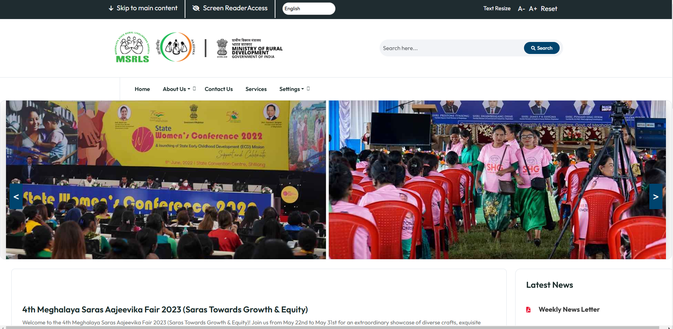Screens :

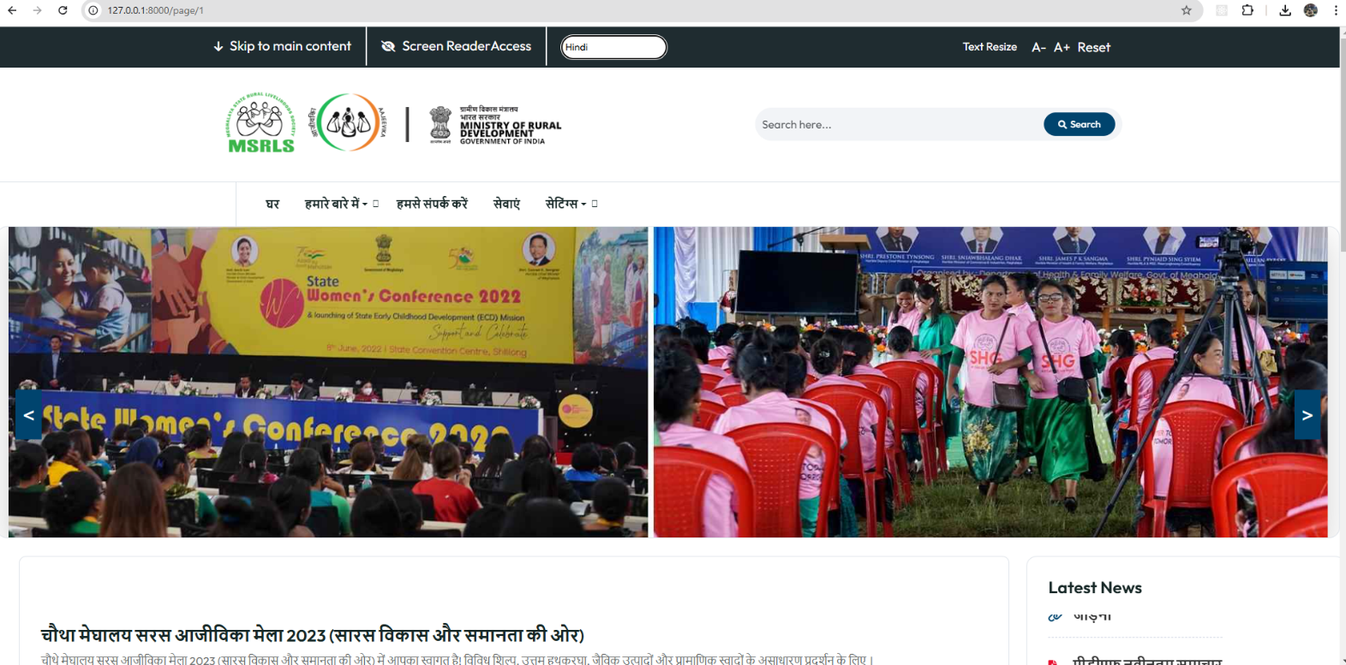Language Change Integration:

Dynamic cards:

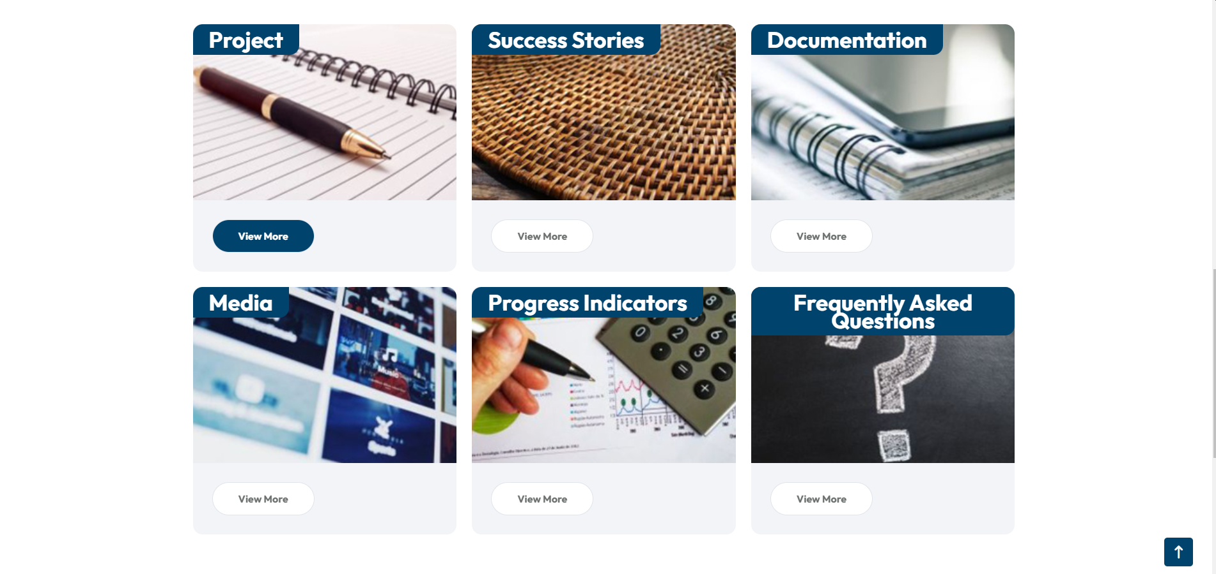

Dynamic Paragraph and Latest New:

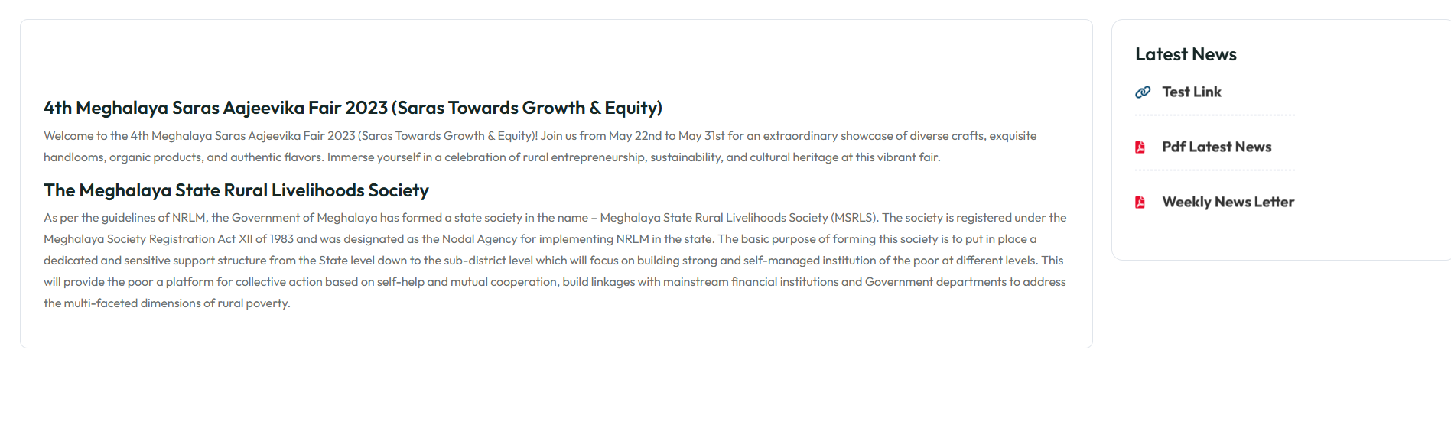

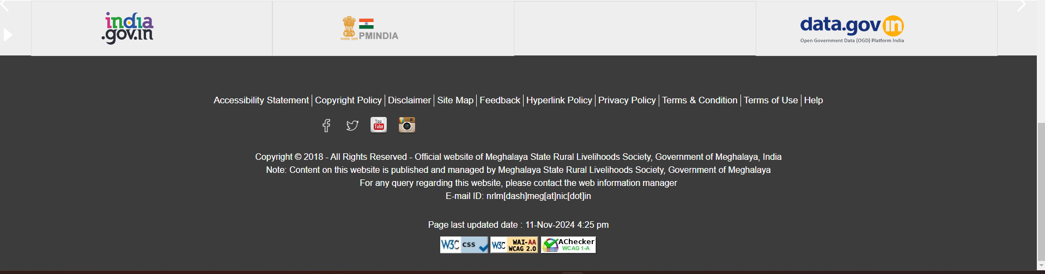Official MSRLS Website footer:

So , I go through the footer table from db, there are type and content columns are there , I di’n't understand how the dynamic footer wil be loaded in msrls format